Ace Athletics Club
Privacy Policy
Introduction
The website/social media page is maintained by Anne-Marie Garcia on behalf of Ace Athletics Club, for the purposes of data protection legislation, Anne-Marie Garcia is the data controller.
We are committed to protecting your privacy and processing your personal data in accordance with the Data Protection Act (DPA) 1988 up to 24 May 2018 and the General Data Protection Regulation (GDPR) on and from 25 May 2018 (Data Protection Legislation). This policy explains how the information we collect about you is used and kept securely. It also explains your privacy choices when using our website as well as your right to access your information under Data Protection Legislation.
It is important that every club makes an inventory of the personal data that it holds and examines it under the following headings:
1. Why is it being held?
2. How was it obtained?
3. Why was it originally gathered?
4. How long is it being retained for? 5. How secure is it?
6. Is it shared with any third parties?
The information we collect about you
We may collect the following information about you through our membership process and our website/social media:
¬ Your name, email address, postal address and any other information you voluntarily provide to us via our online and paper forms for the purpose of registering you as a member of our club or/and entering you in an event that you have chosen to participate in.
The information provided to us
We may be provided with information about you from clubs with which you are registered. That information may include: name, date of birth, gender, email address, address, telephone number, name of the Athletics Ireland affiliated clubs with which you are registered and any coaching qualifications or officiating licenses that you hold (Athletics Data).
How we use your information
We may use your personal information for a number of purposes, including:
¬ To process and manage your membership.
¬ To deal with your requests and enquiries.
¬ To contact you for reasons related to your enquiry.
¬ To notify you about athletic events.
¬ To enter you into AAI competitions
Our legal basis for processing your information
We will process your Athletics Data on the basis of the following legitimate interests:
¬ To provide selected external providers with a facility to check and validate data to support administrative processes. For example:
Transfer of name and date of birth to check membership validation at point of entry to athletics and running events
¬ The transfer of registered members from one club to another. You will maintain the same record but the club name associated with the record will change.
¬ There is an Athletics Ireland administration portal where a selected number of staff can access data to help to respond to queries, update data and perform necessary administration activity. (See Athletics Ireland Privacy Policy 2018)
¬ Providing relevant and necessary information via email, text and post to you about the following:
o Changes to rules and regulation
o Updates to advice and guidance relating to specific roles held within this club
o Transactional information relating to club affiliation and transfers athlete
registration, representative teams, competition and events, coach and officiating licenses, road race licensing, courses, CPD events and qualifications.
If you become a registered athlete with our club, we will share your athletics data with Athletics Ireland so as to facilitate your membership and as part of the administration of your involvement in the sport.
We will share only what is needed for those purposes and, where possible, will anonymise the data before sharing. If we would like to share your information for any other purpose we will ask for your consent.
When we collect information from you, we will tell you if we would like to send you information about our products and services. We will give you the opportunity to opt in to any such communications and will tell you how you can opt-out at any time.
If we wish to share your data with third parties for marketing purposes, we will tell you about this and only do so if we get your consent. You can opt out at any time either by notifying us.
The club may also share your personal information with An Gardai Siochana and other Statutory Agencies for the purposes of crime prevention, crime detection or the safety of our members.
Protecting your information
The data that we collect from you may be transferred to a destination external to Athletics Ireland own secure network. We will not transfer your data outside of the European Economic Area.
By submitting your personal data, you agree to this transfer, storing or processing. We will take all reasonable steps to ensure that your data is treated securely and in accordance with this privacy policy. The Internet is not generally a secure medium for communication and therefore we cannot guarantee the security of any information you send to us over the Internet. We use up-to-date industry procedures to protect your personal information.
Finding out what information this club holds about you
Under the Data Protection Legislation, you can ask to see any personal information that we hold about you. Such requests are called subject access requests. If you would like to make a subject access request, please contact your club Data Protection Officer. You will also need to provide two forms of identification, for example, driving licence, utility bill or passport and, if appropriate, any particulars about the source or location of the information you are requesting. Your club has 30 days to respond to your subject access request.
Data retention
Any data that we collect from you will be deleted in accordance with timescales set out below:
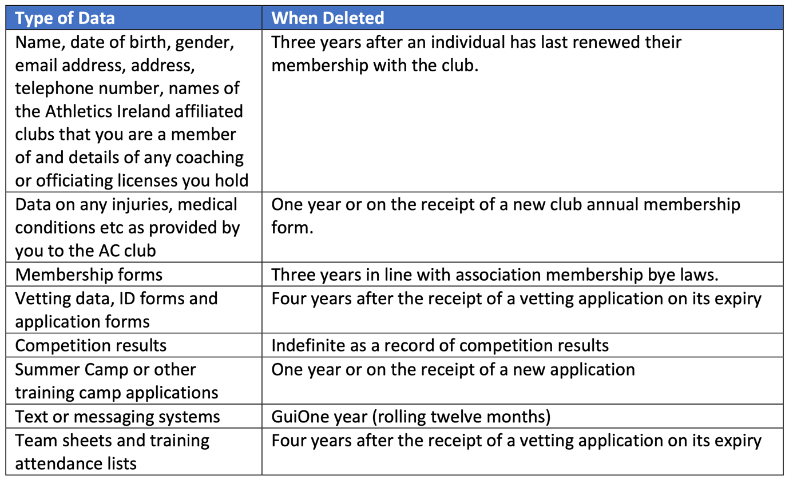
Changes to our Privacy Policy
We regularly review our Privacy Policy and updates will appear on this page when necessary. This Privacy Policy was last updated in May 2018

